- Which pair includes a vector quantity and a scalar quantity?

A frequency; wavelength
B momentum; displacement
C velocity; pressure
D potential energy; young modulus

- All the following quantities have reasonable estimate of magnitudes except for:

A volume of an adult’s head 1500 cm³
B size of a nucleus 1.5 × 10⁻¹⁴ m
C wavelength of orange light 660 nm
D spacing of Young double slits 5 cm

- Theory suggests that the intensity of light I varies with the inverse square of the distance d. Which graph of the results supports this theory?

I
d
A
I
d
B
I
d
C
I
d
D

- The cathode-ray oscilloscope display shows the square waves produced by an electronic circuit. The oscilloscope is set at 100 μs per division.

What is the period of the signal shown?

A 50 μs B 100 μs C 200 μs D 1000 μs

- The volume of a cylindrical wire, V is given by V = cross-sectional area, A × length, L.
The measurements of the cross-sectional area A and length L have an uncertainty of 2% and 3% respectively.
What is the uncertainty in the calculated volume?

A 1.5% B 3 % C 5 % D 6 %

- An experiment is done to measure the acceleration of free fall of a body from rest.
Which measurements are needed?

A the height of fall and the time of fall
B the height of fall and the weight of the body
C the mass of the body and the height of fall
D the mass of the body and the time of fall

- The velocity of a car during the first four seconds of its motion is shown on the graph.
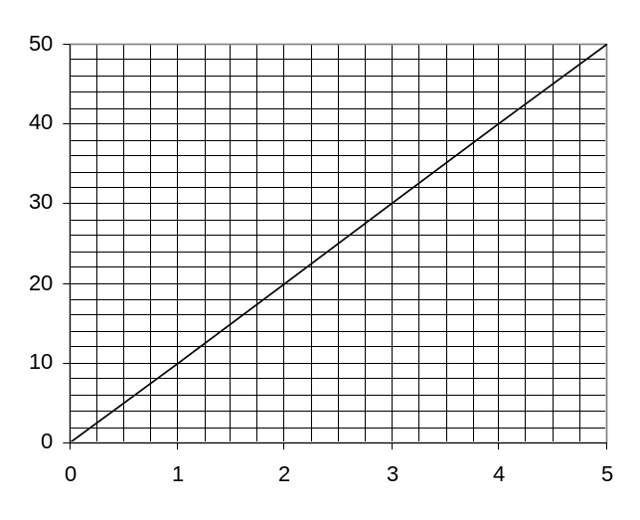
Velocity/ ms⁻¹
Time /s

What is the acceleration of the car at 2 seconds after its departure?

A 10 ms⁻² B 20 ms⁻² C 125 ms⁻² D 250 ms⁻²

- The diagram shows a displacement-time graph for a mass moving up and down on the end of a spring.
Which point represents the displacement of the mass when it is at maximum velocity?
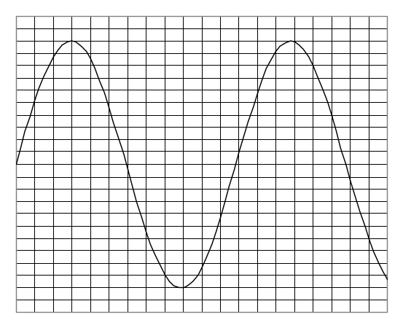
Displacement
up
down
0
B
time
A
C
D

- An example of the application of Newton’s third law of motion is

A A gun recoils when a bullet is shot out from it
B A car slides down a ramp with constant speed
C A sailing boat changes direction when strong wind blows towards it
D An object falls freely with uniform acceleration

- In a collision between two vehicles, it is always true to say that

A the total momentum must be conserved but a small amount of the total kinetic energy may be lost in the collision.
B the total momentum must be conserved if there is no net external force acting on them
C the relative speed of approach between the two vehicles equals their relative speed of separation
D both vehicles must be coupled and moving together

- A railway truck of mass 2m moves with speed v towards another stationary truck of mass 3m. After the collision, both move together along the same direction.
What is the speed of the trucks after the collision?

A 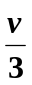 B 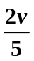 C 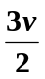 D 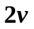

- The diagrams show three forces acting on a body.
Which diagram shows the body in equilibrium?

A
B
C
D

- A force F is applied to a beam at a distance d from a pivot. The force acts at an angle θ to the beam as shown.
pivot
d
F
θ
Which combination will cause the smallest turning effect about the pivot?

 | F | d | θ
A | Large | Large | Large
B | Large | Large | Small
C | Small | Small | Large
D | Small | Small | Small

- A uniform bar of length 3.0 m is pivoted horizontally at its mid-point.

0.5 m
0.8 m
150 N
100 N
Weights are hung from two points on the bar as shown in the diagram. To maintain horizontal equilibrium, a torque is applied.
What is the magnitude and direction of the torque?

A 70 Nm clockwise
B 70 Nm anticlockwise
C 5 Nm clockwise
D 5 Nm anticlockwise

- What is the internal energy of an object?

A It is the energy associated with the object’s movement through space.
B It is the sum of all the microscopic potential and kinetic energies of the molecules.
C It is the energy due to the attractions between the molecules within the object.
D It is the energy associated with the random movement of the molecules in the object.

- A motorist travelling at 15 ms⁻¹ can bring his car to rest in a braking distance of 20 m.
What is the initial speed of the car if he brings the car to rest in a distance of 80 m using the same braking force?

A 4 ms⁻¹
B 30 ms⁻¹
C 40 ms⁻¹
D 60 ms⁻¹

- A stone of weight 2.0 N in the Earth’s gravitational field is moved from P to Q and then to R along the path shown.
60 m
80 m
100 m
P
Q
R
Earth’s surface
How much potential energy does the stone lose?

A 120
B 200
C 280
D 1200

- In an experiment to demonstrate Brownian motion, smoke particles in a container are illuminated by a strong light source and observed through a microscope.
The particles are seen as small specks of light that are in motion.
What causes the Brownian motion?

A Collisions between the smoke particles and the walls of the container
B Collisions between the smoke particles and air molecules
C Convection currents within the air as it is warmed by the light source
D Kinetic energy gained by the smoke particles on absorption of light.

- A graph of stress versus strain is plotted for an elastic material.

strain
stress

Which one of the following correctly relates the features of the graph to the physical quantities?

 | Gradient | Area under the graph
A | Young modulus | Strain energy
B | Young modulus | Strain energy per unit volume
C | Spring constant | Elastic potential energy per unit volume
D | Spring constant | Strain energy

- The graph shows the behaviour of a sample of a metal when it is stretched to an extension of 10 mm.
Extension/mm
Force/N
2
10
0
0

What one of the following correctly describes the sample?

A the sample breaks when a force of 2 N is exerted
B less than 0.010 J of work is done to stretch the sample
C the sample does not obey Hooke’s Law but it is elastic
D the force constant is 0.5 kNm⁻¹.

